**Hypothesis testing:** Hypothesis means assumption.

In order to validate the assumptions, we use Hypothesis testing.

**Steps in finding out the Hypothesis testing:**

1. **Null Hypothesis : Default value / Default state**

**Example: Toss a coin**, i.e coin is fair or not

Here default state is “**coin is fair”**.

Hence here, null hypothesis is”**coin is fair”**.

1. **Alternate Hypothesis:** Opposite value of null hypothesis**.**

From the above example, we can say that**; “coin is not fair”** is **alternate hypothesis.**

1. **Perform some experiments.**

**Ex**: Out of 100 attempts, if we get head for 80 times, and another time min if we get head of 20 times.

Here we can define the confidence interval (CI**).** In real time domain experts will define this confidence interval.

**Confidence Interval (CI): [20 – 80]**

Next time if we toss the coin again, out of 100 attempts, if we get only 10 times head, then we can say that, **null hypothesis is rejected.**

It means that **alternate hypothesis is accepted.**

Let us take another example**: Whether the person is criminal or not.**

* **Null hypothesis:** Persona is not criminal. (Default state)
* **Alternate Hypothesis:** Person is not criminal. (Opposite of null hypothesis**.**
* **Experiments/ proofs:** DNA, finger print, weapon, eye witness, footage, judgment etc**.**
* Based on above proofs, will come to one conclusion.

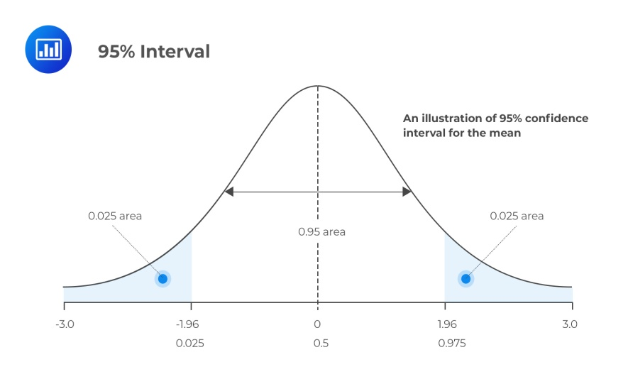

From the above graph: Confidence interval (CI) is 95%.

If our conclusions are fall under the 95% or above the 95% we reject the null hypothesis.

This means that, we fail to accept the null hypothesis.

**In other words**

* If our conclusions are **within the CI**, we fail to reject the null hypothesis.
* If our conclusions are **outside of the CI**, we reject the null hypothesis.

**Point estimate:**

The value of any statistics that estimates the value of a parameter is called point estimate.

**P- value:** A p-value measures the probability of obtaining the observed results, assuming that the null hypothesis is true.

The lower the p-value, the greater the statistical significance of the observed difference.

In general **p-value of 0.05** or **lower** is considered statistically significant.